

28

Target: ___/28 or ____ % 👍 👎

Year 9 HASS- Geography

40

40

***Task 5 Part A: In Class Assessment Fieldwork Theory***

***And Skills Assessment (2.5 % weighting)***

***Reading Time: 5 minutes & Working Time: 35 minutes***

Name: Teacher:

1. What type of photograph is Source 3? **(1 mark)**

______________________________________________________________________

1. Describe what is shown in Source 1. Consider cultural (built) features and natural (physical) features. **(4 marks)**

______________________________________________________________________________________________________________________________________________________________________________________________________________________________________________________________________________________________________________________________________________________________

__________________________________________________________________________________________________________________________________________________________________________________________________________________

______________________________________________________________________

1. Describe what is shown in Source 2. Consider cultural (built) features and/or natural (physical) features. **(4 marks)**

______________________________________________________________________________________________________________________________________________________________________________________________________________________________________________________________________________________________________________________________________________________________

__________________________________________________________________________________________________________________________________________________________________________________________________________________

______________________________________________________________________

1. Explain the change that has happened over time between Source 1 and Source 2.

**(6 marks)**

______________________________________________________________________________________________________________________________________________________________________________________________________________________________________________________________________________________________________________________________________________________________

______________________________________________________________________________________________________________________________________________________________________________________________________________________________________________________________________________________________________________________________________________________________

________________________________________________________________________________________________________________________________________________________________________________________________________________________________________________________________________________________

______________________________________________________________________________________________________________________________________________________________________________________________________________________________________________________________________________________________________________________________________________________________

__________________________________________________________________________________________________________________________________________________________________________________________________________________

**SOURCES: Refer to the following images to answer Assessment 5A.**

**Please do not mark this page.**

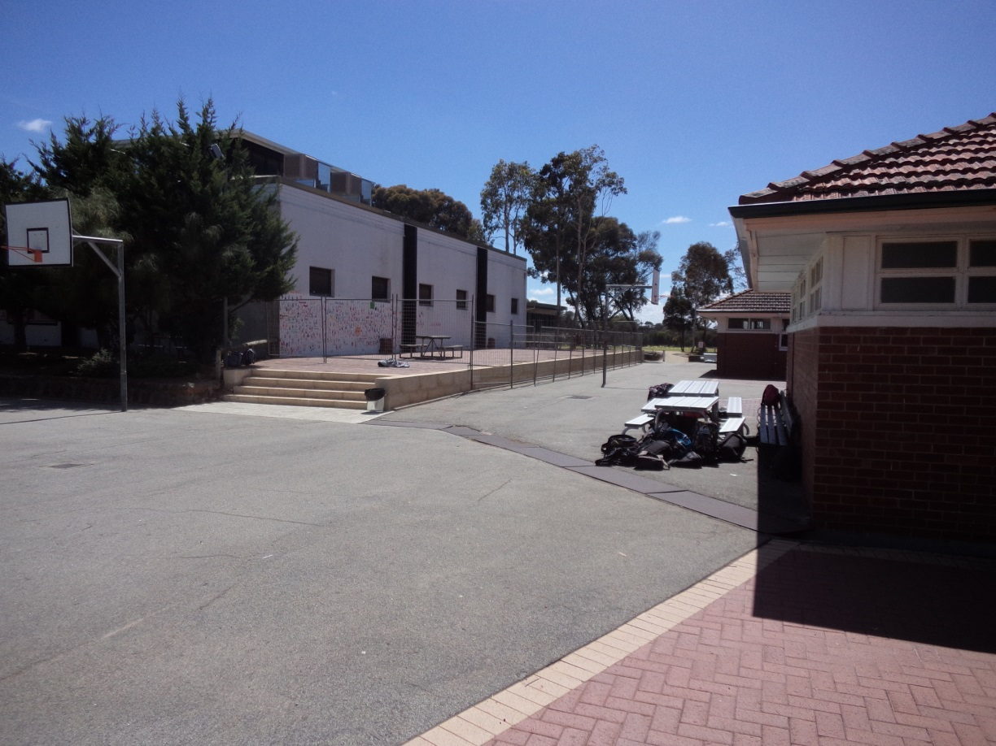

**Source 1:**

**Around 2016**

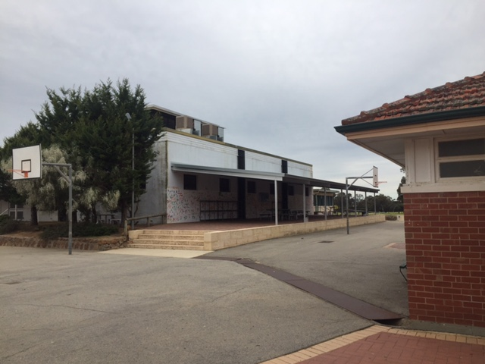

**Source 2:**

**2017**

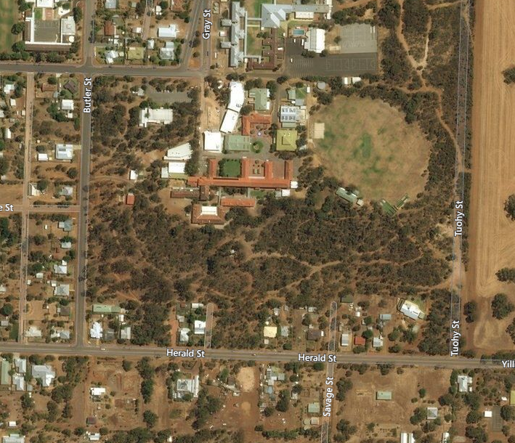

**Source 3:**

My Map Street View, <http://mymapstreetview.com/earth/?t202id=3199&c1=GGS-MyMapST&t202kw=google%20earth&gclid=EAIaIQobChMImNfvyI2k1gIVDr69Ch0k2geYEAAYASAAEgKB5_D_BwE>, retrieved on 14/9/17

**Source 4:**

